
A Project of The International Center
www.newforestsproject.org

WORLD SEED PROGRAM
SEED DISTRIBUTION REPORTING

Once you have finished distributing the seeds, please send the following information back to us.

1) Background information

Organization Name: Ayiti konsè Vèt (AKV)
Country: Haiti
Contact Person: DECEUS Wedly Pierre
Best way to contact you (phone or email): (509) 3757-6174, (509) 32250488
Deceus.wedly@gmail.com / deceus.wedly@yahoo.fr
Skype : wedlyakv01

2) Seed Arrival
- Date seeds were received: July 01,2013
- Name of the person(s) in charge of receiving the seeds: DECEUS Wedly Pierre
- How were the seeds stored?: in a dry place

3) Species and Amounts Received
Total amount of seeds received (in kilograms): 9 kg
List all species and amounts received of each one:
Albizia Lebbeck 0.50 Kg
Cajanus Cajan 2.25 Kg
Cassia siamea 0.50 Kg
Dalbergia sissoo 0.50 Kg
Grevillea Robusta 0.50 Kg
Gliricidia sepium 1.00 Kg
Leucaena Leucocephala 1.00 Kg
Moringa oleifera 2.75 Kg

4) Seed Distribution
Please describe how the seeds were distributed by filling in the separate table included in the second page of this document, using one row for each person/organization who received seeds. If your organization used the seeds for its own nursery you can list it as well in the table.
The seeds were distributed to many organization. See the second page.

5) Seed Germination
- If available, please give us an idea of the percentage of seeds that germinated for each species. If you had any seeds that did not germinate well, please let us know, as well as why you think that was the case (i.e. quality of seeds was not good, seeds took too long to arrive and may have been damaged, did not get the right amount of water, etc).

5) Pictures
Please include pictures of the following:
- Bags of seeds received initially
- Distribution of seeds (people receiving the seeds)
- Pictures of the projects, nurseries and communities benefiting from the seed distribution.
If you have digital pictures that you are including in the report please mail these in as well in separate jpeg (or similar) file, so that we can more easily use them in our newsletters, website and fundraising efforts.

6) Other Comments_Future Plans
Please include any other information you wish to provide us that is relevant to your current work or future reforestation efforts.

7) Seed Distribution Table
Please complete the follwing information

Date seeds were distributed  Month/day/year | Name of Person, Group and/or Organization receiving the seeds. | Amount of NFP seeds distributed to person/organization  (approximate grams or number of seeds) | Type of project seeds will be used for
07/02/2013 | Ayiti konsevet (AKV) | 2Kg | Reforestation
07/04/2013 | Initiative pour le Developpement Durable d’Haiti (IDDH) | 2 Kg | Reforestation
07/06/2013 | ASSEDEC Cange | 2 Kg | Reforestation
07/12/2013 | Ecole de Technique Agricole de Marmelade | 1 Kg | Nurserie
07/17/2013 | Universite Chretienne du Nord d’Haiti (UCNH) | 1 Kg | Nurserie
07/19/2013 | Centre Technique de Limonade | 0.5 Kg | Nurserie
07/22/2013 | Groupement des Planteurs de Dondon (GPD) | 0.5 Kg | Reforestation

If necessary, add more rows to table.

If you would like to receive more seeds from the New Forests Project (up to 5 kilograms) complete the table below:

Organization’s Name:
Contact Person (name and email):
Today’s Date:

Species | Quantities (in grams or kilograms)

Acacia auriculiformis
Albizia lebbeck
Acacia nilotica
Acacia Senegal
Acacia tortilis
Cajanus cajan | 2 Kg
Cassia siamea
Dalbergia sissoo
Grevillea robusta (max amount 500 grams)
Gliricidia sepium | 1 Kg
Leucaena leucocephala | 1 Kg
Moringa oleifera | 1.5 Kg
Prosopis juliflora
Robinia pseudoacacia
Other species (if agreed with NFP staff)

Total Amount | 5.5 Kg
If you would like to receive larger quantities please contact World Seed Program staff

SIX MONTH FOLLOW UP REPORTING.

Please send the following:
- Brief description of projects where New Forests Project seeds were used
- Description of the success rate of seed germination and tree survival
- Description of any problems encountered in germinating the seeds, growing the seedlings and establishing trees. Pictures of the seedlings and young plants would be very useful.
- Include any further information you think may be relevant including further needs that the reforestation projects might have.

Feel free to send us any anecdotal information or reports that might be available.
Thank you!

PHOTO Galery
Different uses of the seed into different nurseries, marmalade, and mena plezans

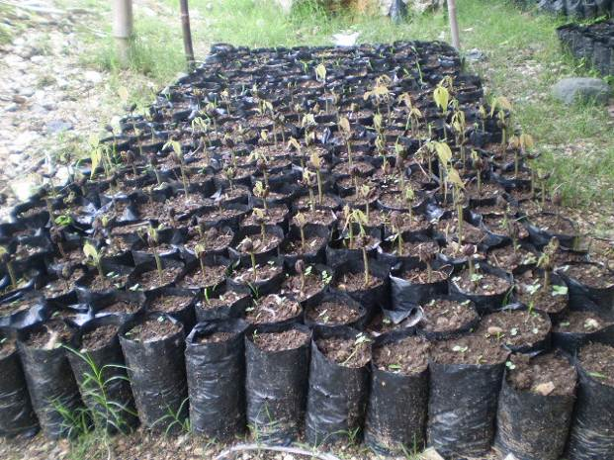 marmalade nurserie

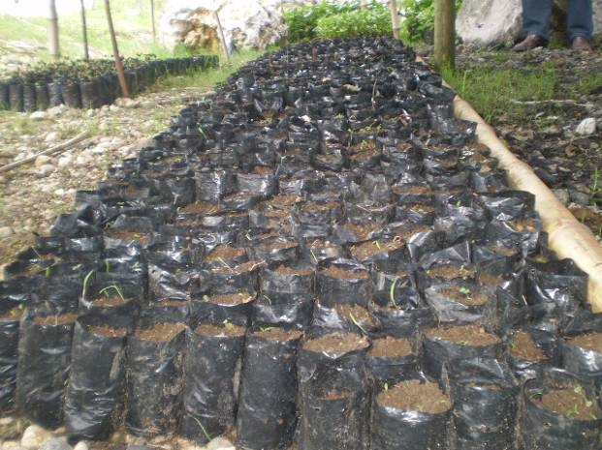

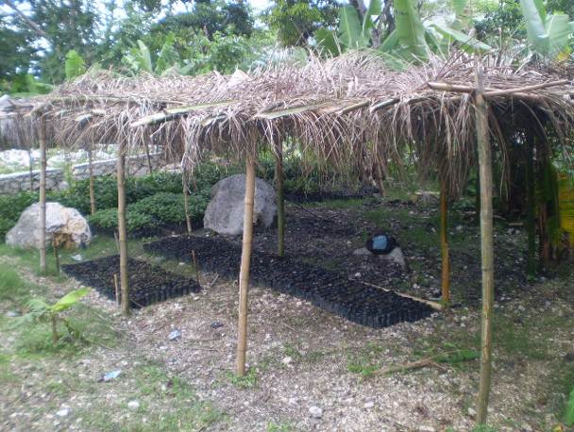
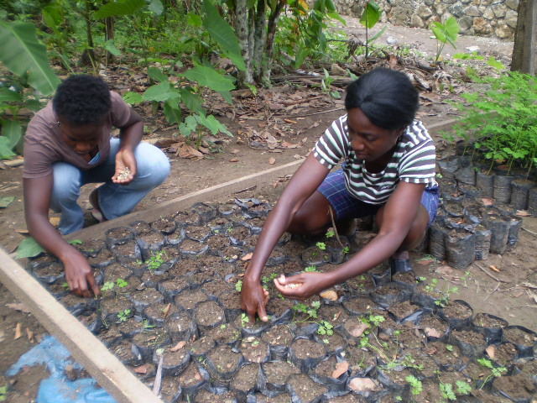 mena nurserie

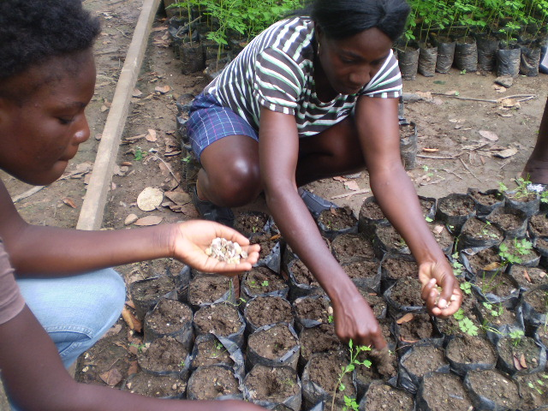

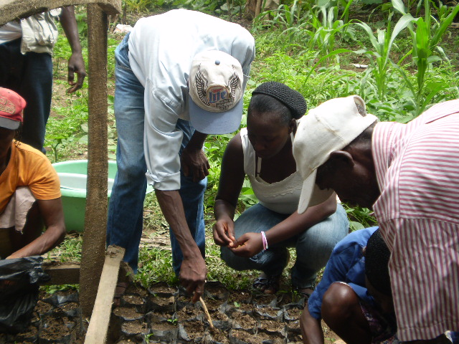

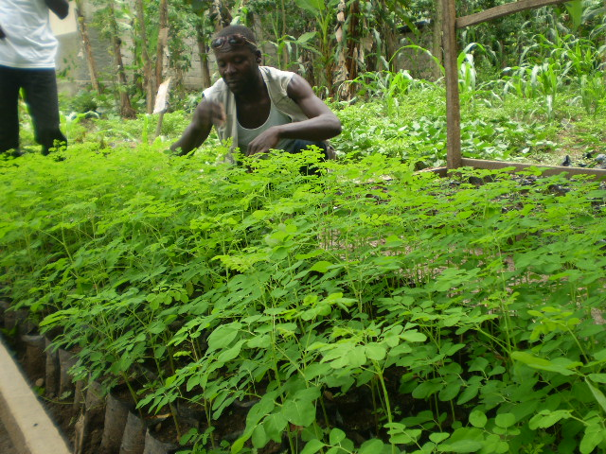 day of the distribution (Moringa)

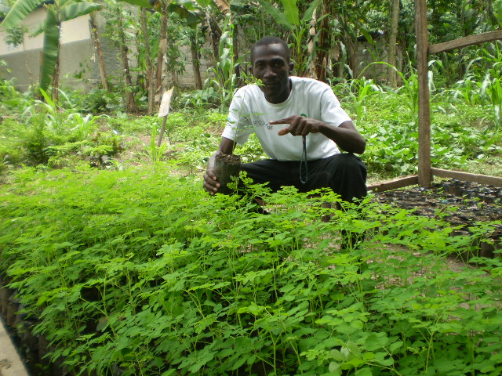

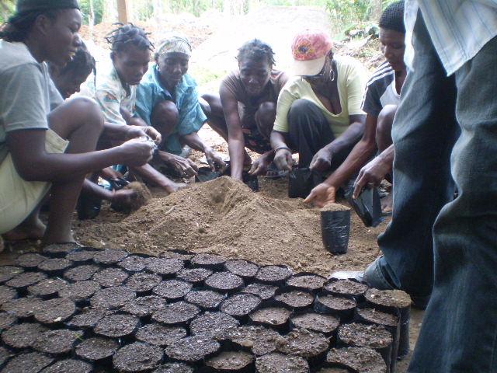 soil preparation for a nurserie.

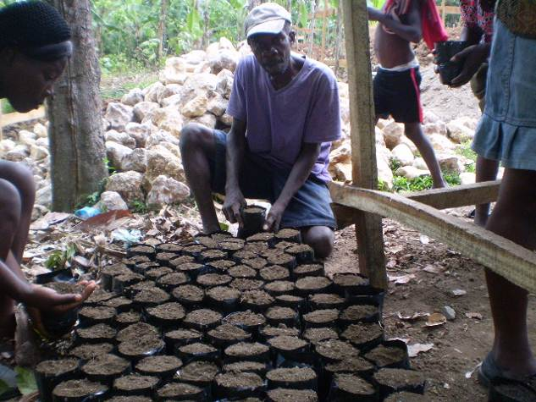

Thank you for your help
DECEUS Wedly Pierre, Agr.
AKV’s Coordinator

